# Objectives

At the end of this lab, you will be able to

* Add an Arduino device to a network and configure the basic network settings
* Access an Arduino device on a network
* Create an Arduino webserver
* Use an Arduino to obtain information from the Internet

# Procedure

In this lab, you will be testing out a series of different sketches to see different ways an Arduino can be used as a host on a network. Thanks to various Ethernet libraries, it is nearly as easy to add an Arduino to a network as it is to add a PC. The same principles still apply, the Arduino needs a physical address, it needs a network address, it needs a subnet mask and it needs a way to physically connect to the network.

The assignment of the various addresses and masks are done through the Arduino sketch and the physical connection to the network is usually done using an Ethernet shield of some kind which plugs into the Arduino board. e.g.: <https://www.robotshop.com/ca/en/w5100-ethernet-shield.html>:

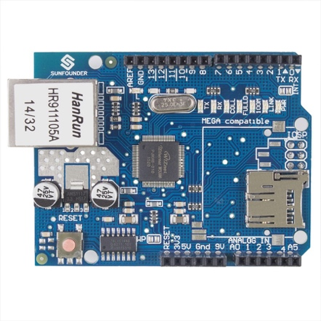

An Arduino Ethernet Shield[1]

**As you work through the activities, there are a series of checkpoints and activities. Please make sure to have the points recorded with your instructor and answer questions in RED.**

## Ethernet – Webserver

To answer some of the questions below, you may need to go to the Arduino page that describes the Ethernet library: <http://arduino.cc/en/Reference/Ethernet>

1. Start the Arduino program, and open the Webserver sketch under File→Examples→Ethernet→Webserver
2. The examples sketches are read-only, so save the sketch to your own folder so that you can save any changes that you make.
3. Find the line of code that sets the MAC address of the Arduino board.

What are the advantages and disadvantages that the Arduino MAC address has over a NIC MAC address?

It is a soft MAC, and can be changed.

Make any adjustments to the MAC address that are necessary and make note of those adjustments here:

Original from example code: 0xDE, 0xAD, 0xBE, 0xEF, 0xFE, 0xED

Changed to MAC on back of ethernet shield: 0x90, 0xA2, 0xDA, 0x00, 0x7C, 0x74

1. Find the line of code that sets the IP address of the Arduino board.

What is different about the way the Arduino sets its IP address compared to the way you set the IP address on a PC in previous labs?

IP is set to a C++ object.

Make any adjustments to the IP address that you feel are necessary and make note of those adjustments here (if you did nothing, then state that you made no changes):

Removed example IP so it will be assigned by the router to prevent IP conflicts.

1. The code in the example Webserver sketch does not explicitly set the address of the gateway, instead the software uses the default value of xxx.yyy.zzz.1 where xxx, yyy, and zzz are the first three octets of the address set in the previous step. Does this gateway address match the address of the gateway you are using?

It will when I set the router IP address to match!

The function call Ethernet.begin(mac, ip); sets the MAC address and IP address of the Arduino, but leaves the gateway at its default value. To force the Arduino to use a different gateway, use the call

Ethernet.begin(mac, ip, gateway);

where gateway is defined as an IP address in the same way that the variable ip is.

Make any adjustments to the code that you feel are necessary and make note of those adjustments here (if you did nothing, then state that you made no changes):

No changes.

1. The code in the Webserver sketch does not explicitly set the subnet mask, instead it uses the default value of 255.255.255.0. Does this subnet mask match the subnet mask that is required?

It will when I change the subnet mask of the router to match!

The function call Ethernet.begin(mac, ip, gateway); sets the MAC address, IP address, and gateway of the Arduino, but leaves the subnet mask at its default value. To force the Arduino to use a different subnet mask, use the call

Ethernet.begin(mac, ip, gateway, subnet);

where subnet is defined as an IP address in the same way that the variable ip is.

Make any adjustments to the code that you feel are necessary and make note of those adjustments here (if you did nothing, then state that you made no changes):

No changes.

1. The Webserver sketch uses the Ethernet library provided with the Arduino IDE and has many calls to functions in the Ethernet library. Read through the Webserver sketch and look for the different calls to functions in the Ethernet library.

What do the following function calls do? Write a brief comment/summary about each command.

Ethernet.begin(mac, ip); Starts ethernet connection and server, set MAC and IP

Ethernet.begin(mac); Starts ethernet connection and server, set MAC

server.begin(); Start server

server.available(); Get connected client that has data available for reading

client.read(); Read data from client

client.println(); Print data from client followed by new line

client.print(); Print data from client

client.stop(); Disconnect client

1. Configure a network like this using the wireless ISR, your computer, and your Arduino (you don’t need to connect to the WAN for this part of the lab):



Using the USB network adapter to connect your computer to the ISR. You will need to configure the ISR and your computer so that you will be able to communicate with the Arduino.

1. Upload the Webserver code to your Arduino board
2. Open up a browser and connect to the Arduino board. Use the URL http://<ipaddress_of_board>.
3. Change the Arduino code so that the webpage displays something more personal. E.g.:

**Welcome to <Your_Name>’s Arduino Webserver**

1. Upload the code to the Arduino, reconnect to the webserver with your browser and show your new webpage to your instructor. Take a screen shot of your browser connecting to the Arduino webserver and paste it here:

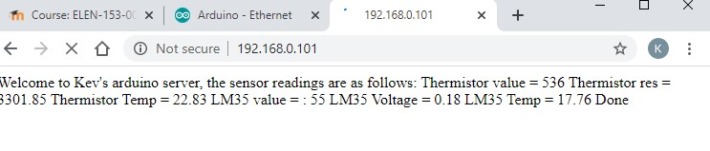

## DHCP

The Ethernet library also provides support for the Arduino to obtain all of its IP information automatically using DHCP. To do this requires a call to the Ethernet.begin function with only the MAC address as an input:

Ethernet.begin(mac);

1. Change the webserver code so that it uses DHCP to set up the IP address, subnet mask and gateway of the Arduino.

Why do you not need to set the IP Address, subnet mask and default gateway this time?

I did this from the start, it obtains the IP, SNM, and gateway from the router using DHCP

1. Determine the following pieces of information about your Arduino board:

MAC address: 0x90, 0xA2, 0xDA, 0x00, 0x7C, 0x74

IP Address: 192.168.0.101

Subnet Mask: 255.255.255.0

Default Gateway: 192.168.0.1

## Ethernet – UdpNTPClient

1. Start the Arduino program, and open the UdpNtpClient sketch under File→Examples→Ethernet→ UdpNtpClient.
2. The example sketches are read-only, so save the sketch to your own folder so that you can save any changes that you make.
3. Configure a network like this using the ISR, a computer, and an Arduino. Connect the WAN side of the ISR to the OC network (Ethernet cable labelled “WAN”)



1. Read through the code, change the IP address, MAC address, default gateway and subnet mask if required and then upload the sketch to your Arduino. What does this sketch do?

Sends and receives NTP packets of information via UDP

1. What is the primary difference about the communication channel used in this example compared to the communication channel used in the other examples? Hint: think about the transport layer.

This operates over UDP at layer 4 instead of layers 1 & 2 via ethernet

1. **Change the time displayed to local time. Show your results to your instructor.**

Moodle will not accept .zip folders so I cannot include my code, here is a github link to the code files and screenshot etc.  
  
<https://github.com/kcorbett95/lab7.git>

## Clean Up!

Make sure that the Machines are connected back into the college network and the users can login to the Domain.

***END OF LAB EXERCISE***

1. Image source: https://www.robotshop.com/ca/en/w5100-ethernet-shield.html